**Project work**

**of**

**Computer**

**Submitted by Submitted to**

*Aditya Pratap Singh Mr. Akash Dubey*

*Class-11th B*

*Roll no-04*

**CERTIFICATE**

**This certifies that Aditya Pratap Singh of Class 11th B have completed his project work of computer Science successfully. This is also to certify that this is the individual work of the candidate.**

**Acknowledgement**

I would like to express my special thanks of gratitude to my teacher Mr.Akash Dubey as well as our principal Mr. Jim Thomas who gave me the golden opportunity to do this wonderful project on Computer Programs, which also helped me in doing a lot of research and I came to know about so many new things I am really thankful to them.

Secondly I would also like to thank my parents and friends who helped me a lot in finalizing this project within the limited time frame.

**PROGRAM 1**

**WRITE A JAVA PROGRAM TO PRINT ALL FOUR DIGIT TECH NUMBER. THE PROCESSOR TO FIND OUT A TECH NUMBER IS AS FOLLOWS:-**

**2025 = (20+25)2 = 2025**

**HENCE, 2025 IS A TECH NUMBER.**

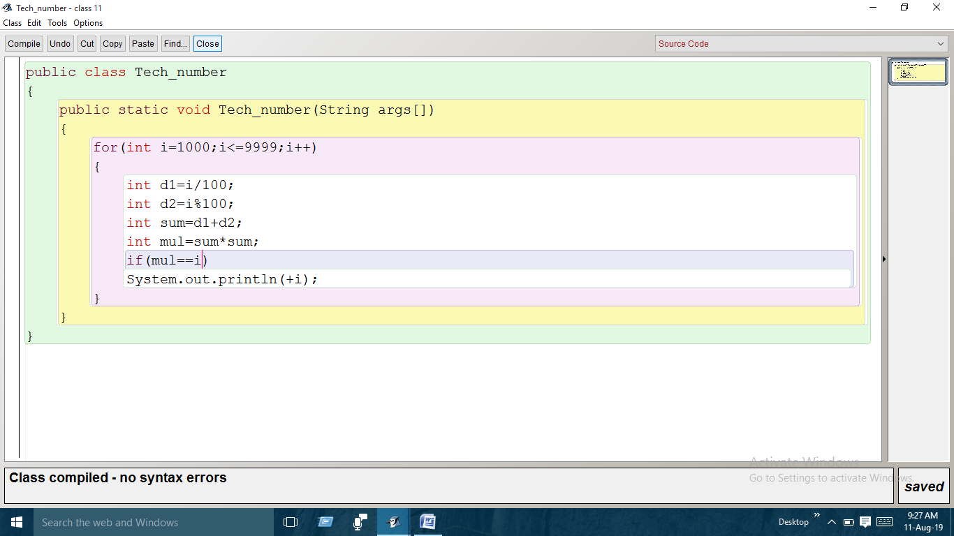

**PROGRAM 2**

**WRITE A PROGRAM TO INPUT A SENTENCE AND CONVERT IT INTO UPPERCASE AND COUNT AND DIPLAY TH TOTAL NUMBER OF WORDS STARTING WITH THE LETTER ‘A’.**

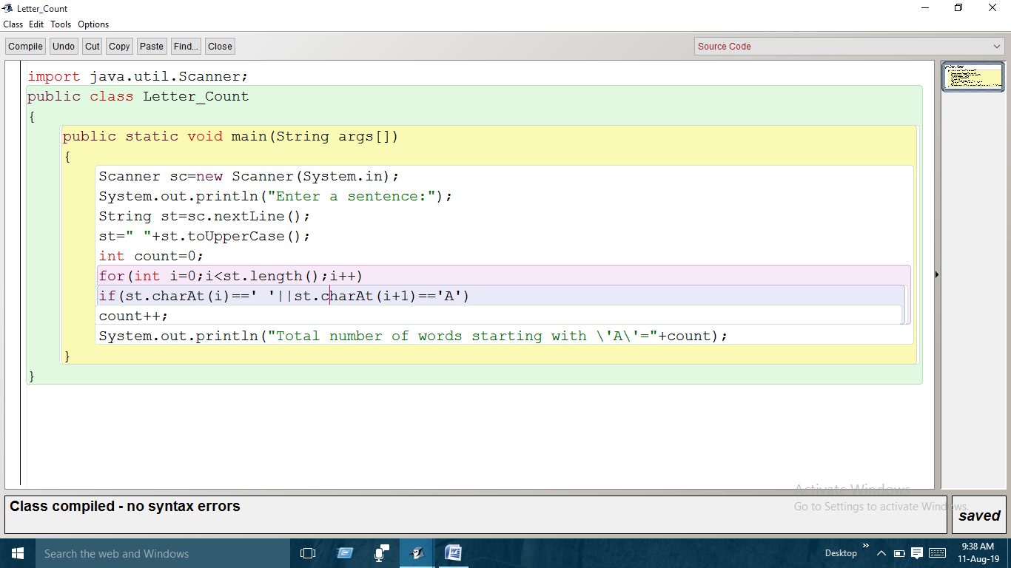

**PROGRAM 3**

**WRITE A PROGRAM TO CHECK WHETHER A SENTENTENCE ENDS WITH AN APPROPRIATE SIGN (‘!’ OR ’.’ OR ’?’) OR NOT.**

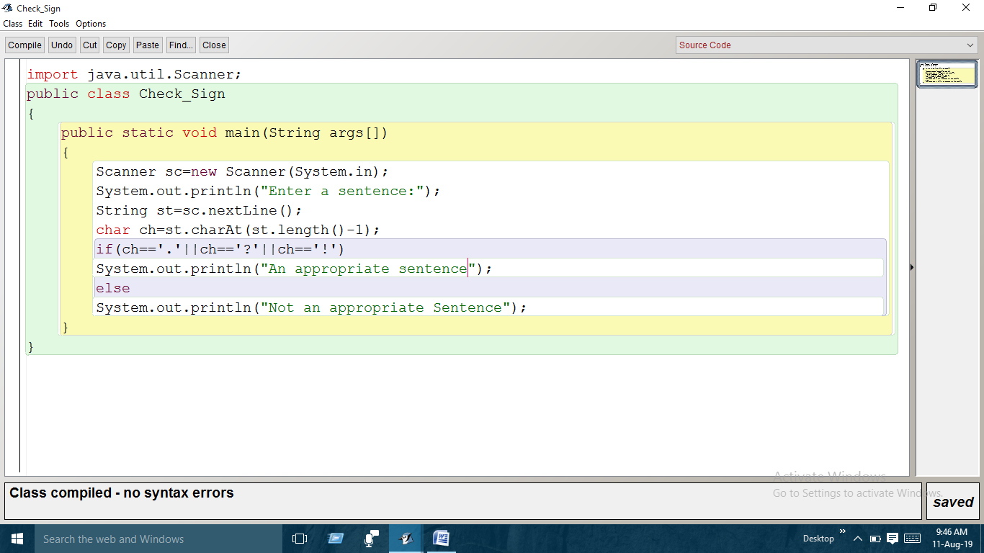

**PROGRAM 4**

**WRITE A PROGRAM JAVA PROGRAM TO INPUT A DECIMAL NUMBER AND CONVERT IT INTO BINARY NUMBER.**

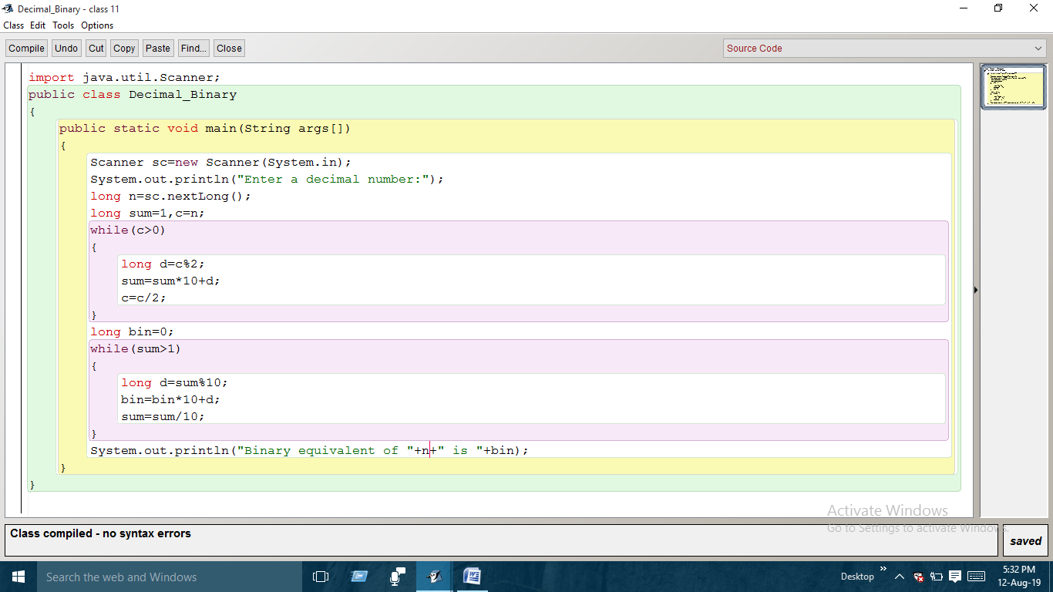

**PROGRAM 5**

**WRITE A JAVA PROGRAM TO INPUT A BINARY NUMBER AND CONVERT IT INTO DECIMAL NUMBER.**

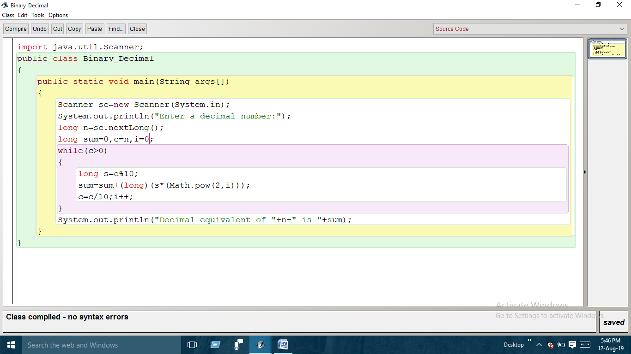

**Program 6**

**WRITE A LOOPING PROGRAM TO PRINT ANY STRUCTURE.**

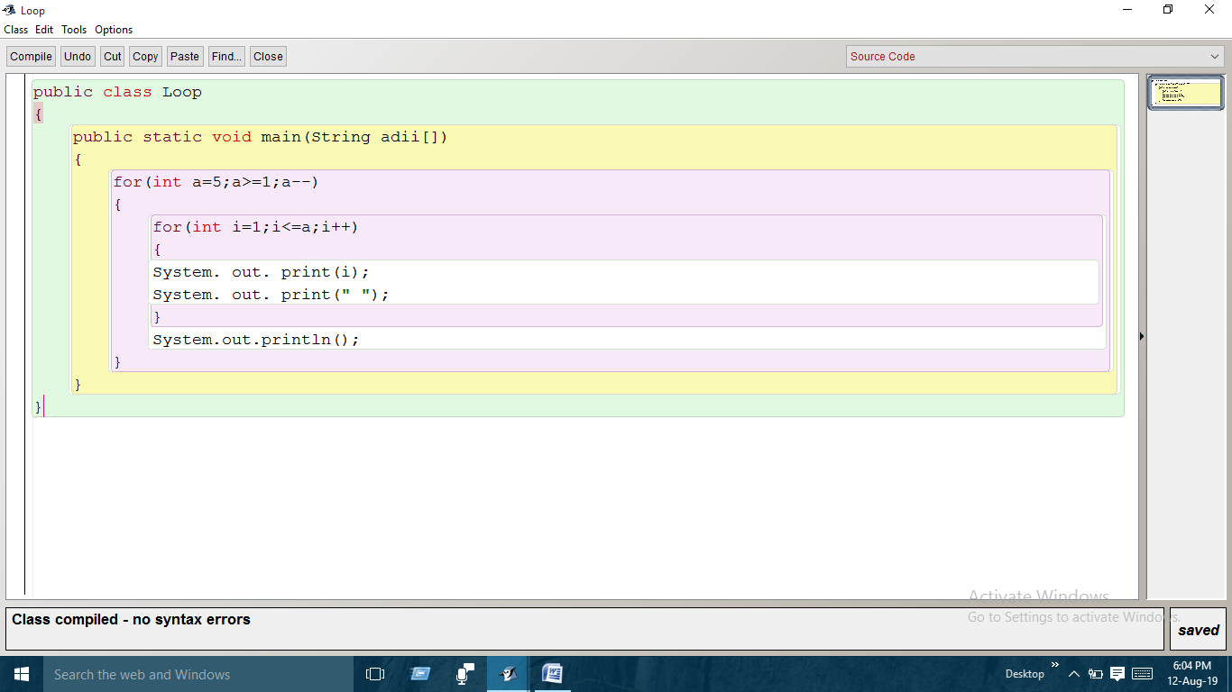

**PROGRAM 7**

**WRITE A JAVA PROGRAM TO PRINT THE NUMBER OF WORDS IN THE HIGHEST FREQUENCY WORD.**

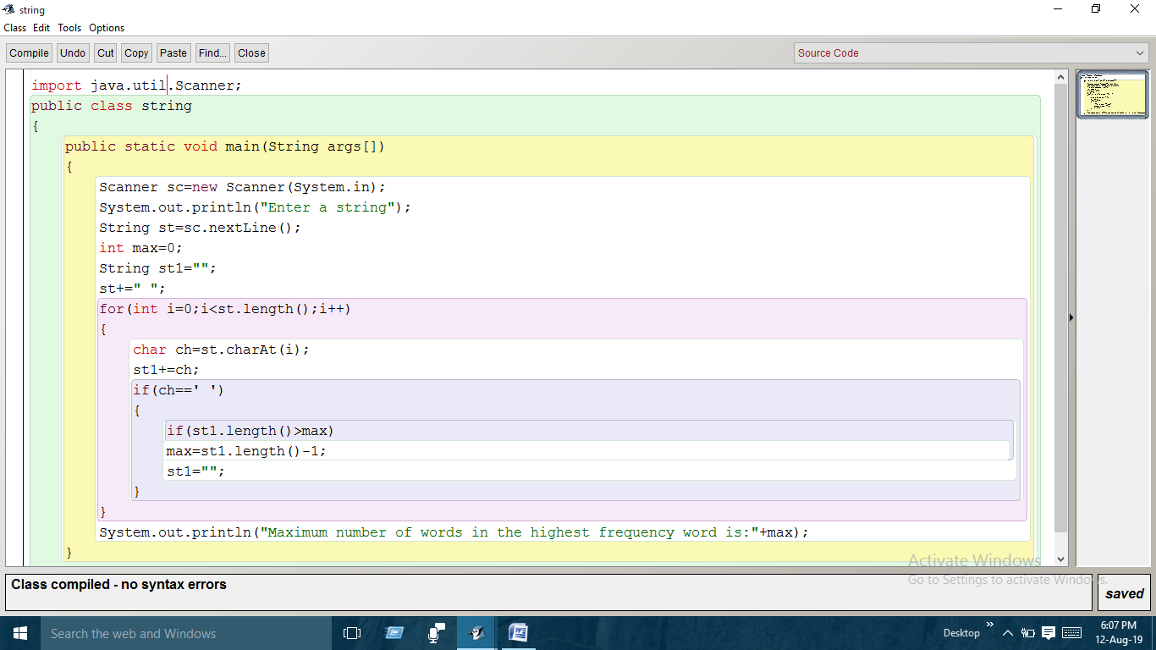

**PROGRAM 8**

**WRITE A JAVA PROGRAM TO CHECK WHEATHER A NUMBER IS PRONIC OR NOT. PRONIC NUMBER ARE THE PRODUCT OF TWO CONSEQUENT NUMBERS.**

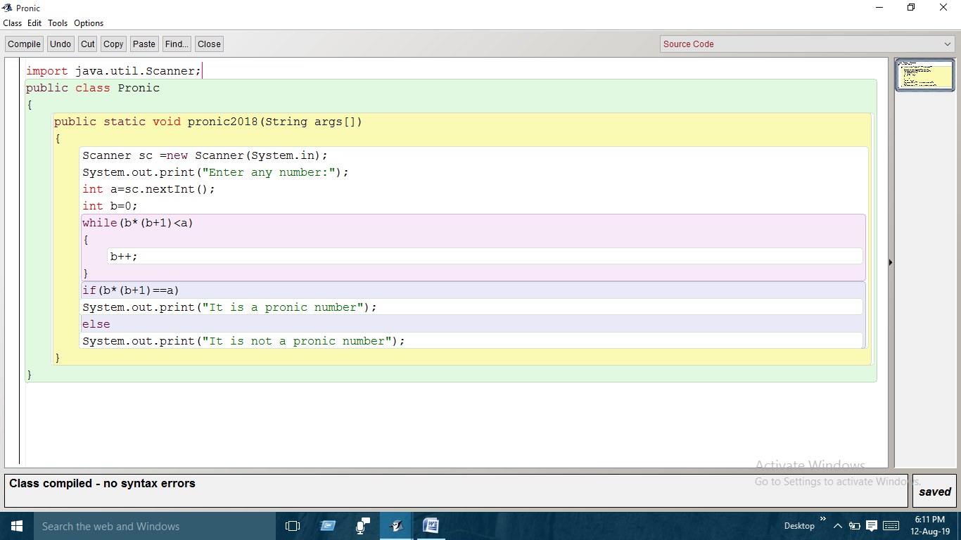

**PROGRAM 9**

**WRITE A JAVA PROGRAM TO CHECK THE LARGEST ELEMENT IN THE ARRAY OF NUMBERS.**

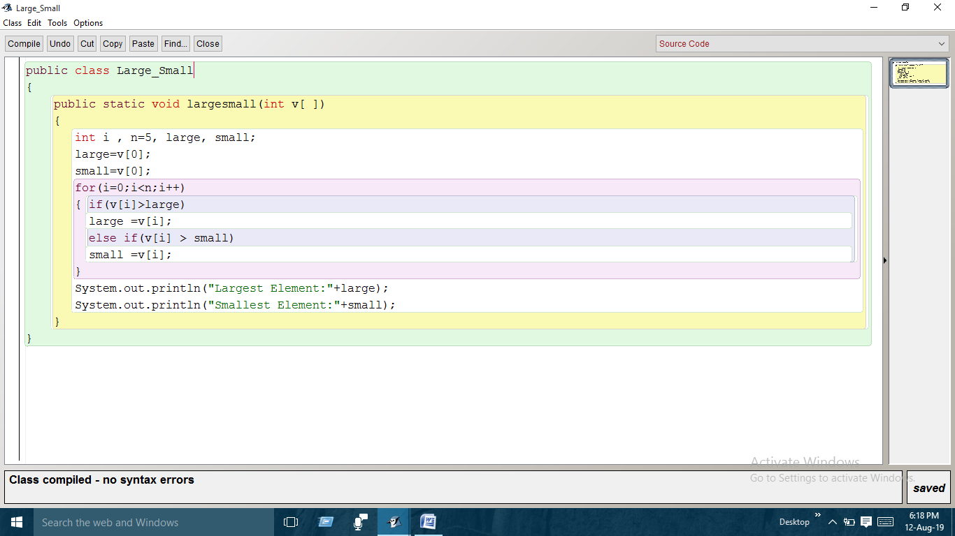

**PROGRAM 10**

**WRITE A JAVA PROGRAM TO CHECK ISBN NUMBER. IT IS THE SUM (DIVISIBLE BY 11) OF ALL THE CHARACTERS OF ISBN WHERE ALL THE CHARACTERS ARE THE PRODUCT OF THEM AND THIER CONSEQUENT.**



**PROGRAM 11**

**WRITE A JAVA PROGRAM TO CHECK WHETHER A NUMBER IS PALINDROME NUMBER OR SPECIAL NUMBER OR BOTH.**

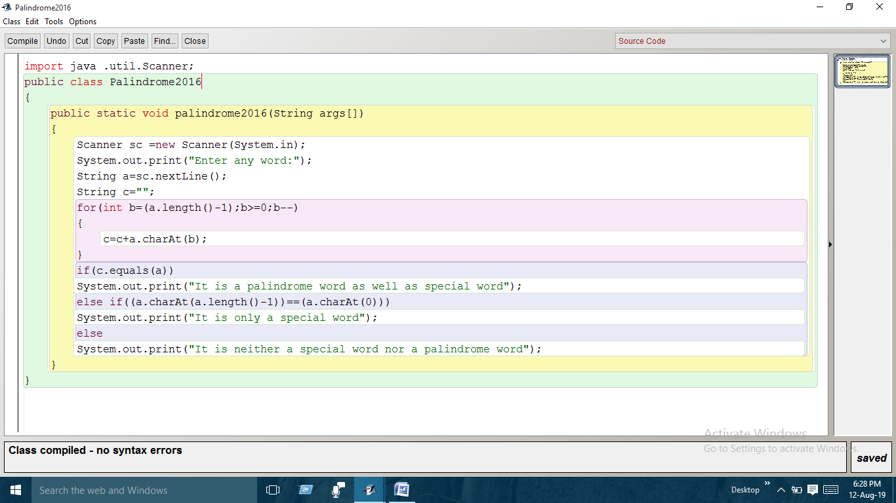

**PROGRAM 12**

**WRITE A JAVA PROGRAM TO CHECK A NUMBER IS SPY OR NOT. SPY NUMBER IS THAT NUMBER WHOSE DIGIT’S SUM IS EQUAL TO PRODUCT.**

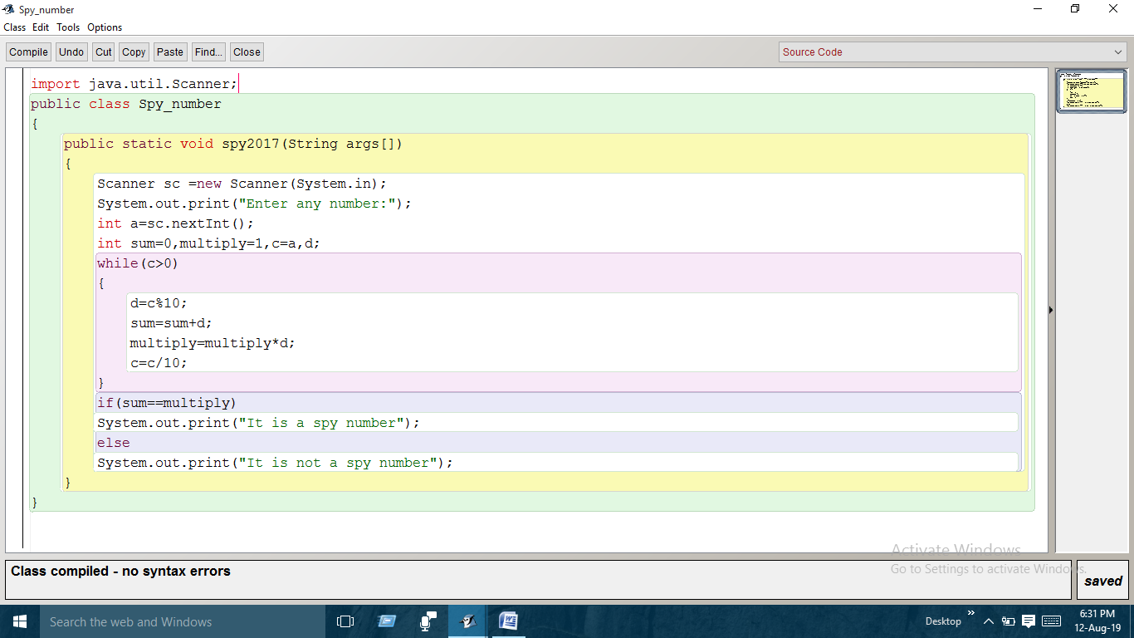

**PROGRAM 13**

**WRITE A JAVA PROGRAM TO CHECK WHETHER A NUMBER IS EVEN OR ODD IF AND ONLY THEN WHEN ANOTHER NUMBER IS LESS THEN FIRST NUMBER.**

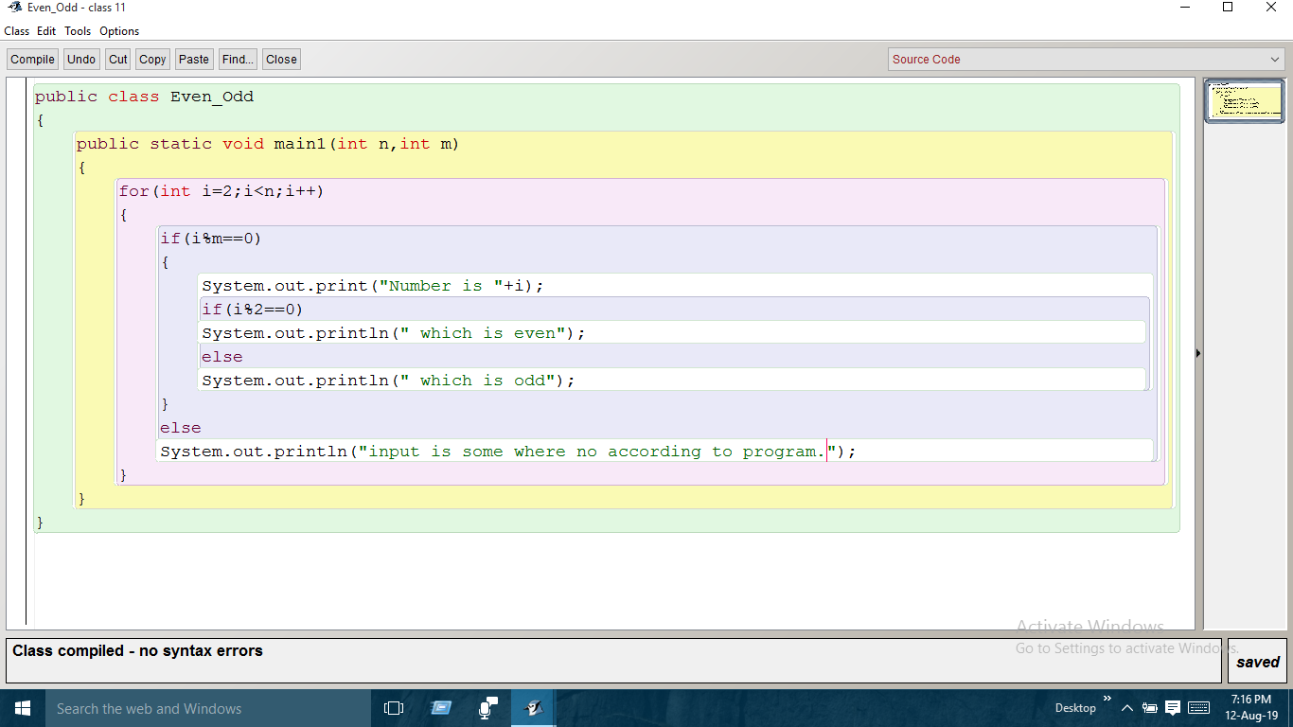

**PROGRAM 14**

**WRITE A JAVA PROGRAM TO CONVERT A NUMBER INTO PALINDROME (REVERSE OF IT).**

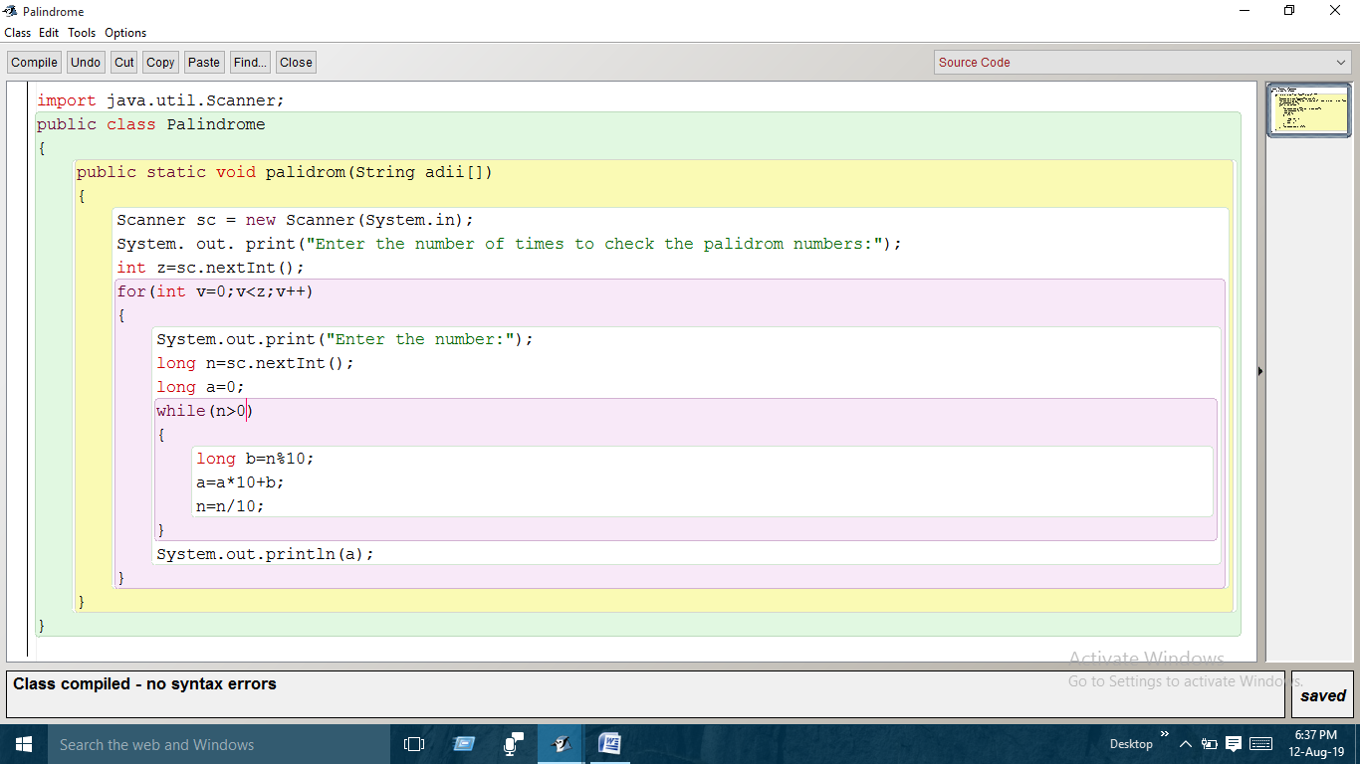

**PROGRAM 15**

**WRITE A JAVA PROGRAM TO TAKE LCM OF TWO NUMBERS.**

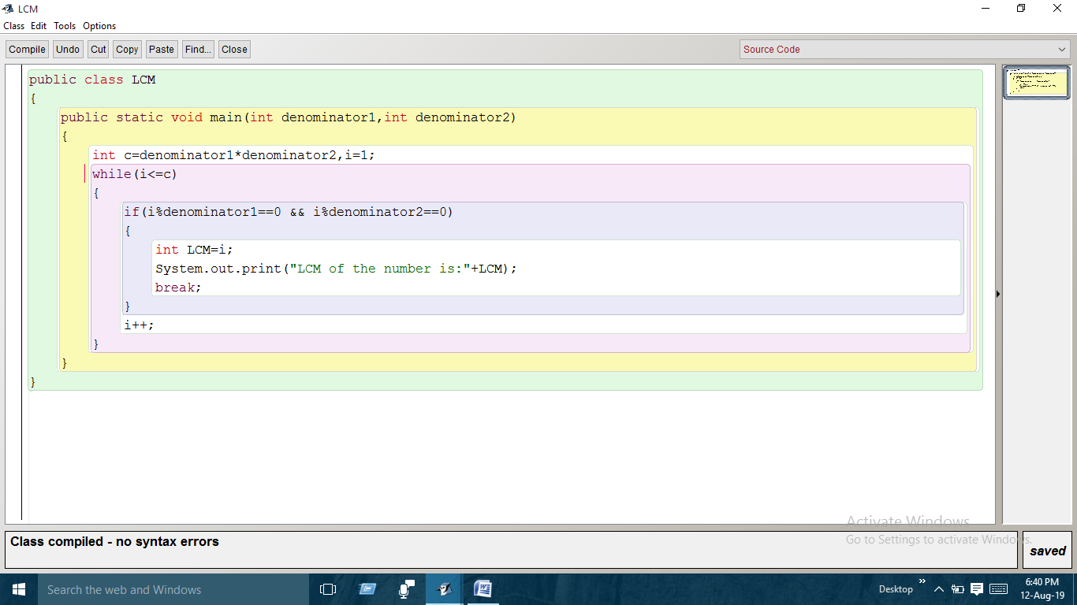

**Bibliography**

**Following are the resources which helped me a lot in finalizing the project work in the limited time frame:-**

* **Computer book**
* **My laptop**

**And others.** 